EWMA correlation: GBPUSD and USDCAD
Method 06 / daily log returns / lambda = 0.94 / Alpari D1 full available history

Study setup
Logical pair: GBPUSD , USDCAD
Broker symbols: GBPUSD_i , USDCAD_i
Snapshot: 2026-11-03_majors_alpari_D1
Timeframe: D1
Matched return window: 1999-01-05 to 2026-11-02 (UTC bar dates)
Matched return count n: 7205
Dropped unfinished last bar dated 2026-11-03 UTC after a tick-volume check against the prior complete day.
Lambda: 0.94 (today weight 0.06)
Burn-in ignored in path summaries and chart: first 60 updates
Mean adjustment: each leg demeaned by its mean on the matched rows
Seeds: c_0 = v_x,0 = v_y,0 = 0
Complete matched rows (Excel): GBPUSD-USDCAD_EWMA_D1.xlsx
Complete matched rows (HTML table): GBPUSD-USDCAD_EWMA_D1_data.html

Method carried forward
EWMA correlation updates covariance and variances of mean-adjusted daily log returns of close, ln(close_t / close_t-1), with lambda = 0.94 (6% weight on today's product or square, 94% on yesterday's EWMA state). Quotes are not inverted. Each leg is demeaned by its mean on the matched rows; that mean uses the full sample, so the rho path is a full-sample description, not a live filter. Seeds start at zero. Path summaries and the chart ignore the first 60 updates so the zero seed has faded. The headline is rho on the last day. rho is symmetric under swap of the two symbols. A high |rho| does not prove cause, lead-lag, or a trading signal. Today's return sits inside today's rho, so the estimate can only inform a later decision. Same-sample Pearson r is a side check only.

Results
Latest EWMA rho: -0.635453
Post-burn-in path (n=7145): mean=-0.410721, median=-0.451318, min=-0.889292, max=0.503537, std=0.239610
Share of post-burn-in days with |rho| >= 0.4: 57.61%; |rho| >= 0.7: 7.00%
Same-sample Pearson r: -0.456462
Latest rho minus r: -0.178990

Conclusion
Over 7205 matched daily log-return rows for GBPUSD and USDCAD (broker quote directions unchanged), latest EWMA rho with lambda=0.94 is -0.6355 (negative, moderate recent linear link in this sample). After a 60-day burn-in, path mean is -0.4107, std is 0.2396, and the range is [-0.8893, 0.5035]. Same-sample Pearson r is -0.4565 (latest rho minus r = -0.1790). This does not establish cause, lead-lag, or a lasting trading rule.

Charts
Daily closes

Daily log returns
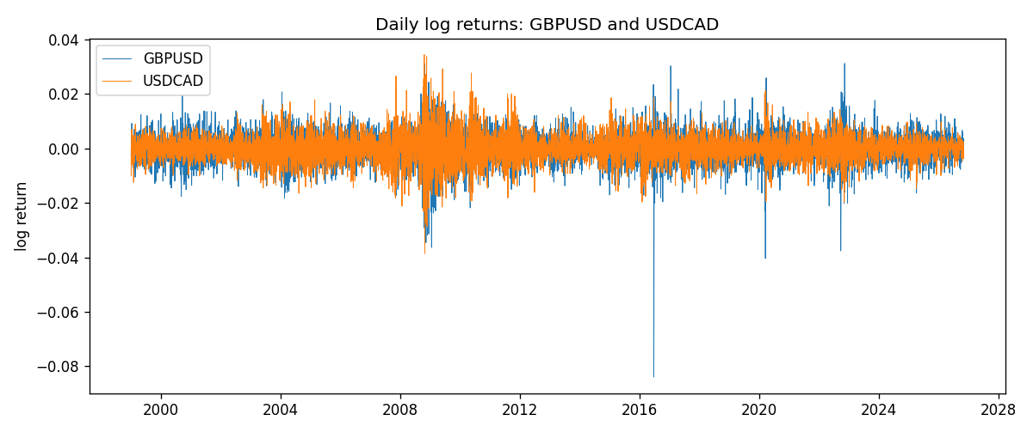
EWMA rho path with Pearson r reference
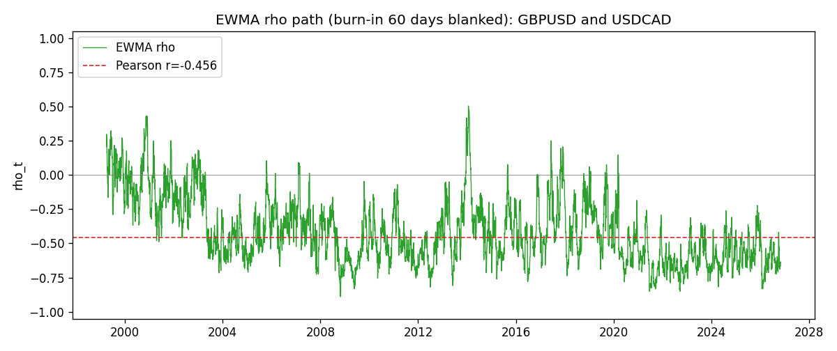

Data report
Every matched row that entered the EWMA recursion is stored in the sibling Excel workbook named GBPUSD-USDCAD_EWMA_D1.xlsx. That file is the complete data archive for redrawing charts. Embedding all rows as a Word table is impractical at this length; the Word file holds the column list, column summaries, and the first and last 15 matched rows.
Columns: time, GBPUSD_open, USDCAD_open, GBPUSD_high, USDCAD_high, GBPUSD_low, USDCAD_low, GBPUSD_close, USDCAD_close, GBPUSD_tick_volume, USDCAD_tick_volume, GBPUSD_spread, USDCAD_spread, GBPUSD_real_volume, USDCAD_real_volume, GBPUSD_log_return, USDCAD_log_return, GBPUSD_x_demeaned, USDCAD_y_demeaned, c_t, v_x, v_y, rho_t
Column summaries (matched calculation rows)
column | count | mean | std | min | 25% | 50% | 75% | max
GBPUSD_open | 7205 | 1.5161639 | 0.2182756 | 1.06854 | 1.32505 | 1.51142 | 1.63205 | 2.1066
USDCAD_open | 7205 | 1.2670469 | 0.16900802 | 0.9168 | 1.119 | 1.29857 | 1.3723 | 1.6183
GBPUSD_high | 7205 | 1.5224596 | 0.21884187 | 1.08366 | 1.32981 | 1.5182 | 1.6384 | 2.1161
USDCAD_high | 7205 | 1.2719479 | 0.16896591 | 0.9336 | 1.1234 | 1.30394 | 1.3769 | 1.619
GBPUSD_low | 7205 | 1.5098441 | 0.21750249 | 1.03518 | 1.31956 | 1.50336 | 1.62444 | 2.0983
USDCAD_low | 7205 | 1.2624879 | 0.16904619 | 0.9056 | 1.1144 | 1.29361 | 1.36793 | 1.6102
GBPUSD_close | 7205 | 1.5162333 | 0.21823062 | 1.06879 | 1.3252 | 1.5114 | 1.6322 | 2.1065
USDCAD_close | 7205 | 1.2670655 | 0.16898286 | 0.916 | 1.11851 | 1.29871 | 1.37253 | 1.6137
GBPUSD_tick_volume | 7205 | 94776.836 | 153518.92 | 62 | 9986 | 52867 | 91739 | 1273370
USDCAD_tick_volume | 7205 | 80835.261 | 147176.39 | 37 | 5509 | 40849 | 71515 | 1410818
GBPUSD_spread | 7205 | 26.978348 | 19.192834 | 0 | 11 | 20 | 50 | 50
USDCAD_spread | 7205 | 23.508952 | 18.282466 | 0 | 9 | 17 | 40 | 60
GBPUSD_real_volume | 7205 | 3.5541156e+09 | 8.441481e+10 | 0 | 0 | 0 | 0 | 2.4038164e+12
USDCAD_real_volume | 7205 | 1.8330194e+10 | 9.6578305e+10 | 0 | 0 | 0 | 0 | 2.5751613e+12
GBPUSD_log_return | 7205 | -2.188e-05 | 0.00563988 | -0.08388241 | -0.00312535 | 3.221e-05 | 0.0031749 | 0.03112653
USDCAD_log_return | 7205 | -1.219e-05 | 0.00514402 | -0.03859748 | -0.00283601 | 4.92e-05 | 0.00272763 | 0.03436319
GBPUSD_x_demeaned | 7205 | -0 | 0.00563988 | -0.08386053 | -0.00310346 | 5.41e-05 | 0.00319678 | 0.03114841
USDCAD_y_demeaned | 7205 | -0 | 0.00514402 | -0.03858529 | -0.00282382 | 6.139e-05 | 0.00273982 | 0.03437538
c_t | 7205 | -1.323e-05 | 2.051e-05 | -0.00027127 | -1.539e-05 | -8.61e-06 | -4.07e-06 | 1.138e-05
v_x | 7205 | 3.178e-05 | 3.403e-05 | 4.9e-07 | 1.747e-05 | 2.382e-05 | 3.33e-05 | 0.00052547
v_y | 7205 | 2.644e-05 | 3.12e-05 | 3.69e-06 | 1.173e-05 | 1.802e-05 | 2.906e-05 | 0.00040856
rho_t | 7205 | -0.40458727 | 0.24887265 | -0.88929209 | -0.59480227 | -0.44887475 | -0.26758626 | 1
First 15 matched rows (selected columns)
time | GBPUSD_close | USDCAD_close | GBPUSD_log_return | USDCAD_log_return | GBPUSD_x_demeaned | USDCAD_y_demeaned | c_t | v_x | v_y | rho_t
1999-01-05 | 1.6547 | 1.5123 | -0.0028966287 | -0.010131666 | -0.0028747464 | -0.010119475 | 1.7454554e-06 | 4.9585002e-07 | 6.1442262e-06 | 1
1999-01-06 | 1.6537 | 1.5118 | -0.00060452184 | -0.0003306769 | -0.00058263961 | -0.00031848604 | 1.6518619e-06 | 4.8646716e-07 | 5.7816586e-06 | 0.98496488
1999-01-07 | 1.6502 | 1.5141 | -0.002118709 | 0.0015202092 | -0.0020968268 | 0.0015324 | 1.3599595e-06 | 7.2108007e-07 | 5.5756541e-06 | 0.67824456
1999-01-08 | 1.6405 | 1.511 | -0.0058954193 | -0.0020495197 | -0.005873537 | -0.0020373289 | 1.9963415e-06 | 2.7477215e-06 | 5.4901574e-06 | 0.51399168
1999-01-11 | 1.6312 | 1.5057 | -0.0056851331 | -0.0035137769 | -0.0056632509 | -0.0035015861 | 3.0663827e-06 | 4.5072029e-06 | 5.8964142e-06 | 0.59481075
1999-01-12 | 1.6349 | 1.5157 | 0.0022657001 | 0.0066194721 | 0.0022875824 | 0.006631663 | 3.7926282e-06 | 4.5507527e-06 | 8.1813666e-06 | 0.62156382
1999-01-13 | 1.6499 | 1.5226 | 0.0091330396 | 0.0045420214 | 0.0091549218 | 0.0045542123 | 6.066678e-06 | 9.3064632e-06 | 8.9349356e-06 | 0.66529292
1999-01-14 | 1.6531 | 1.5332 | 0.0019376331 | 0.0069376546 | 0.0019595153 | 0.0069498455 | 6.519777e-06 | 8.9784574e-06 | 1.1296861e-05 | 0.64737064
1999-01-15 | 1.6502 | 1.5245 | -0.0017558204 | -0.0056905671 | -0.0017339382 | -0.0056783762 | 6.7193476e-06 | 8.6201424e-06 | 1.2553686e-05 | 0.64592821
1999-01-18 | 1.6522 | 1.526 | 0.0012112405 | 0.00098344542 | 0.0012331227 | 0.00099563627 | 6.3898512e-06 | 8.1941694e-06 | 1.1859943e-05 | 0.64818203
1999-01-19 | 1.6553 | 1.5302 | 0.0018745281 | 0.002748513 | 0.0018964104 | 0.0027607038 | 6.3205858e-06 | 7.9183016e-06 | 1.1605635e-05 | 0.6593361
1999-01-20 | 1.6472 | 1.5211 | -0.0049053846 | -0.0059646885 | -0.0048835023 | -0.0059524976 | 7.6854928e-06 | 8.8741192e-06 | 1.3035231e-05 | 0.71457815
1999-01-21 | 1.6524 | 1.5146 | 0.0031518998 | -0.0042823796 | 0.003173782 | -0.0042701888 | 6.4112043e-06 | 8.9460456e-06 | 1.3347188e-05 | 0.58671769
1999-01-22 | 1.6565 | 1.5184 | 0.0024781662 | 0.0025057712 | 0.0025000484 | 0.002517962 | 6.4042337e-06 | 8.7842974e-06 | 1.2926764e-05 | 0.60099207
1999-01-25 | 1.6585 | 1.5197 | 0.0012066366 | 0.00085579808 | 0.0012285189 | 0.00086798894 | 6.0839601e-06 | 8.347795e-06 | 1.2196363e-05 | 0.60295556
Last 15 matched rows (selected columns)
time | GBPUSD_close | USDCAD_close | GBPUSD_log_return | USDCAD_log_return | GBPUSD_x_demeaned | USDCAD_y_demeaned | c_t | v_x | v_y | rho_t
2026-10-13 | 1.32534 | 1.4214 | 0.0036434319 | -0.0046395653 | 0.0036653141 | -0.0046273744 | -4.9013051e-06 | 9.4698245e-06 | 7.2163387e-06 | -0.59290118
2026-10-14 | 1.31884 | 1.42356 | -0.0049164679 | 0.0015184751 | -0.0048945857 | 0.0015306659 | -5.0567453e-06 | 1.0339053e-05 | 6.9239347e-06 | -0.59766003
2026-10-15 | 1.32757 | 1.41843 | 0.0065976411 | -0.0036101503 | 0.0066195233 | -0.0035979595 | -6.1823472e-06 | 1.2347795e-05 | 7.2852174e-06 | -0.65183462
2026-10-16 | 1.33257 | 1.41357 | 0.0037592051 | -0.0034322068 | 0.0037810873 | -0.0034200159 | -6.5872891e-06 | 1.2464725e-05 | 7.5498948e-06 | -0.67903932
2026-10-19 | 1.33024 | 1.41091 | -0.0017500314 | -0.0018835331 | -0.0017281492 | -0.0018713422 | -5.9980142e-06 | 1.1896031e-05 | 7.3070165e-06 | -0.64333384
2026-10-20 | 1.3377 | 1.40569 | 0.0055923442 | -0.0037066008 | 0.0056142265 | -0.00369441 | -6.8826086e-06 | 1.3073442e-05 | 7.6875154e-06 | -0.68653883
2026-10-21 | 1.33937 | 1.4045 | 0.0012476328 | -0.00084691787 | 0.0012695151 | -0.00083472702 | -6.533234e-06 | 1.2385735e-05 | 7.2680706e-06 | -0.6885853
2026-10-22 | 1.33967 | 1.40081 | 0.00022396082 | -0.0026307268 | 0.00024584305 | -0.002618536 | -6.1798649e-06 | 1.1646218e-05 | 7.2433902e-06 | -0.67284587
2026-10-23 | 1.33684 | 1.40085 | -0.0021146949 | 2.85545e-05 | -0.0020928127 | 4.0745356e-05 | -5.8141894e-06 | 1.1210236e-05 | 6.8088864e-06 | -0.66549338
2026-10-26 | 1.33359 | 1.40093 | -0.0024340661 | 5.7106554e-05 | -0.0024121839 | 6.929741e-05 | -5.4753675e-06 | 1.088674e-05 | 6.4006414e-06 | -0.65592261
2026-10-27 | 1.33044 | 1.40449 | -0.0023648393 | 0.0025379458 | -0.0023429571 | 0.0025501366 | -5.5053371e-06 | 1.0562903e-05 | 6.4067947e-06 | -0.66922457
2026-10-28 | 1.33254 | 1.39911 | 0.0015771808 | -0.0038379274 | 0.001599063 | -0.0038257365 | -5.5420725e-06 | 1.0082549e-05 | 6.9005626e-06 | -0.6644232
2026-10-29 | 1.33733 | 1.39895 | 0.0035881935 | -0.00011436495 | 0.0036100758 | -0.0001021741 | -5.2316795e-06 | 1.0259555e-05 | 6.4871552e-06 | -0.64128301
2026-10-30 | 1.33913 | 1.39751 | 0.0013450605 | -0.0010298736 | 0.0013669427 | -0.0010176827 | -5.0012456e-06 | 9.7560932e-06 | 6.1600666e-06 | -0.6451304
2026-11-02 | 1.3406 | 1.39837 | 0.0010971256 | 0.00061519094 | 0.0011190078 | 0.0006273818 | -4.6590481e-06 | 9.2458583e-06 | 5.8140791e-06 | -0.63545253

